ESSAY STRUCTURAL LOGIC AND ARGUMENT MAPPING

No matter how hard you have thought out every possible counterargument, supporting idea, and vivid example to support your argument, an argument will suffer if you are not able to structure your ideas effectively. Successfully structuring an essay means attending to a reader’s logic, which requires anticipating the reader’s need for information as the argument is delivered. Working through structural logic will help your client find the best way to effectively deliver his or her argument.

Discussing Essay Structural Logic

Talking about your client’s argument in logical terms requires knowing what information is what and where it’s needed. Here are some key words that will help you uncover your client’s logic:

Premise: a statement or idea accepted/assumed as true to be the basis of an argument

Assumption: a point the author does not try to prove

Claim: overall argument of the writer, directing

Refutation: evidence used to negate counterargument and support position

Consequence: the relationship between statements that holds true when one logically "follows from" one or more others

Warrant: an explanation of how/why data supports claim
When tutoring structural logic, take on the role of the reader and ask questions where information is needed or challenge existing information: “Do you think you’ve fully proven your claim?” “What if the reader doesn’t assume the same thing as you do?” “What if they refute your claim/premise with…” These questions will help your client discover the structural importance of each piece of information, the best placement for each piece of information, and how to identify these elements in the future.
Discussing Argument Construction or “Flow”
Understanding the ways the client wrote his or her paper in structural terms can be helpful in identifying strengths and weaknesses of his or her argument. The client may not realize this, but the logic behind structural choices affects the delivery of an argument.
To find the structural logic of an argument, work with your client to map his or her argument (i.e. dissect his or her argument in structural logic terms). Below is an example of argument mapping.
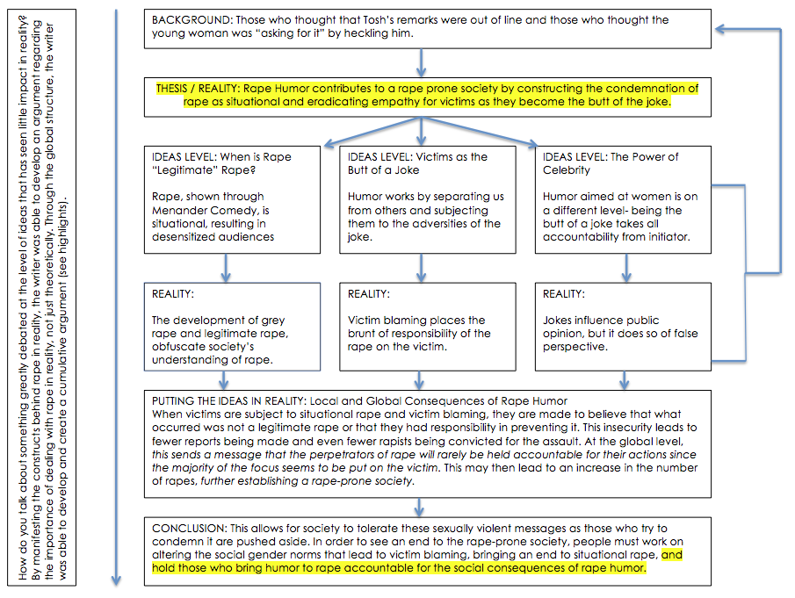
Mapping out an argument relies on the client’s understanding of their own argument and the tutor’s intuition as a reader. The tutor should engage into a conversation with the client about their argument and how and why they structured their paper the way they did. Structures of papers may differ, ranging from before and after, cause and effect, counterargument and refutation, chronological, compare and contrast, but there is not set formula with which to write a paper- a paper’s claim essentially directs its structure. To identify the structure and map the argument, try the following method:
If the client doesn’t have a full draft:
- Identify the thesis or main claim.
- Being listing what the reader needs to know to be convinced by the client’s claim. Ask your client to include pieces of evidence where you think your reader might need something to make your case.
- Work with your client to order your list from the above step. View the work as a reader and think where and what information is needed (ex. Background information for context, a definition, etc.)
- Identify the moves the client used to connect these parts. These may be transitions, evidence, subheadings, etc. Represent these with lines to portray the flow from one part to the next. Ask about the logic behind the moves and flow, such as “How did you connect these two parts?” “What do you think about the flow between the counterclaim and refutation?” “Do you think your reader will be able to follow your logic?”

If the client brings in a full draft:
- Identify the parts of the argument, such as the thesis, background, claims, refutations, comparison, etc. Ask questions about the purposes of the parts to help in grouping. This is similar to backwards outlining.
- Map the parts out in groups and in a way that it is reflective of the paper’s structure. Ask questions such as “Why did you put X where you did?” “Why did you start with the opposing position?”
- Identify the moves the client used to connect these parts. These may be transitions, evidence, subheadings, etc. Represent these with lines to portray the flow from one part to the next. Ask about the logic behind the moves and flow, such as “How did you connect these two parts?” “What do you think about the flow between the counterclaim and refutation?” “Do you think your reader will be able to follow your logic?”
- Identify any gaps or development in the argument as you map these parts out. The gaps should signal underdeveloped parts to the argument and initiate a discussion about how to improve them and tie back into the argument. In the above example, you can see that the conclusion added a third aspect to the argument when the thesis began with two; the writer started out with background information that developed to tie her argument together.

Discussing the Fallacies of the Flow
Once the argument is mapped out, some strengths and weakness should become apparent. You might find your client’s voice, a fresh perspective, or you might find a faulty foundation, unbalanced evidence, or too many assumptions. Map the following paper using Charts, SmartArt, TextBoxes, etc., and answer the questions below.
The debate over athletes’ use of performance-enhancing substances is getting more complicated as biotechnologies such as gene therapy becomes a reality. The availability of these new methods of boosting performance will force us to decide what we value most in sports—displays of physical excellence developed through hard work or victory at all costs. For centuries, spectators and athletes have cherished the tradition of fairness in sports. While sports competition is, of course, largely about winning, it is also about the means by which a player or team wins. Athletes who use any type of biotechnology gives themselves an unfair advantage and disrupt the sense of fair play, and they should be banned from competition.
Researchers are experimenting with techniques that could manipulate an athlete’s genetic code to build stronger muscles or increase endurance. Searching for cures for diseases like Parkinson’s and muscular dystrophy, scientists at the University of Pennsylvania have created “Schwarzenegger mice,” rodents that grew larger-than-normal muscles after receiving injections with a gene that stimulates growth protein. The researchers also found that a combination of gene manipulation and exercise led to a 35% increase in the strength of rats’ leg muscles. (Lamb 13).
Such therapies are breakthroughs for humans suffering from muscular diseases; for healthy athletes, they could mean new world record in sports involving speed and endurance—but at what cost to the integrity of athletic competition? The International Olympic Committee’s World Anti-Doping Agency has become so alarmed about the possible effects of new gene technology on athletic competition that it has blamed the use of gene therapies and urged researchers to devise a test for detecting genetic modification (Lamb 13).
Some biotechicists argue that this next wave of performance enhancement is an acceptable and unavoidable feature of competition. As Dr. Any Miah, who supports the regulated use of gene therapies in sports, claims, “The idea of the naturally perfect athlete is romantic nonsense… An athlete achieves what he or she achieves through all sorts of means—technology, sponsorship, and so on” (qtd. in Rudebeck). Miah, in fact, sees athletes’ imminent turn to genetic modification as “merely a continuation of the way sorts works; it allows us to create more extraordinary performances” as the goal of competition reflects our culture’s tendency to demand and reward new heights of athletic achievement. The problem is that achievement nowadays increasingly results from biological and high-tech intervention rather than strictly hard work.
Better equipment, such as aerodynamic bicycles and fiberglass poles for pole vaulting, have made it possible for athletes to record achievements unthinkable a generation ago. But athletes themselves must put forth the physical effort of training and practice—they must still build their skills—even in the murky area of legal and illegal drug use (Jenkins D11). There is a difference between the use of state-of-the-art equipment and drugs and the modification of the body itself. Athletes who use medical technology to alter their bodies can bypass the hard work of training by taking on the powers of a machine. If they set new records this way, we lose the opportunity to witness sports as a spectacle of human effort and are left marveling at scientific advances, which have little relation to the athletic tradition of fair play.
Such a tradition has long defined athletic competition. Sports rely on equal conditions to ensure fair play, from regulations that demand similar equipment to referees who evenhandedly apply the rules to all participants. If the rules that guarantee an even playing field are violated, competitors and spectators alike are deprived of a sound basis of comparison on which to judge athletic effort and accomplishment. When major league baseball rules call for solid-wood bats, the player who uses a corked bat enhances his hitting statistics at the expense of players who use regulation equipment. When Ben Johnson tested positive for steroids after setting a world record in the 100-meter dash in the 1988 Olympics, his “achievement” devalued the intense training that his competitors had undergone to prepare for the event—and the International Olympic Committee responded by stripping Johnson of his medal and his world record. Likewise, athletes who use gene therapy to alter their bodies and enhance their performance will create an uneven playing field.
If we let athletes alter their bodies through biotechnology, we might as well dispense with the human element altogether. Instead of watching the 100-meter dash to se who the fastest runner in the world is, we might as well watch the sprinters mount motorcycles and race across the finish line. The absurdity of such an example, however, points to the damage that we will do to sports if we allow these therapies. Thomas Murray, chair of the ethics advisory panel for the World Anti-Doping Agency, says he hopes, not too optimistically, for an “alternative future…where we still find meaning in great performances as an alchemy of two factors, natural talents…and virtues” (qtd. In Jenkins D11).
Unless we are willing to organize separate sporting events and leagues—and Olympics, say, for athletes who have opted for a boost from the test tube and another for athletes who have chosen to keep their bodies natural—we should ask from our athletes that they dazzle us less with extraordinary performance and more with the fruits of their hard work.

- What is the writer’s main claim?

- How did the writer structure the paper?

- Why do you think the writer structured his argument that way?

- Do you think, as a reader, the writer effectively delivered his argument?

- What would you have done differently, and what did you think he did well?

